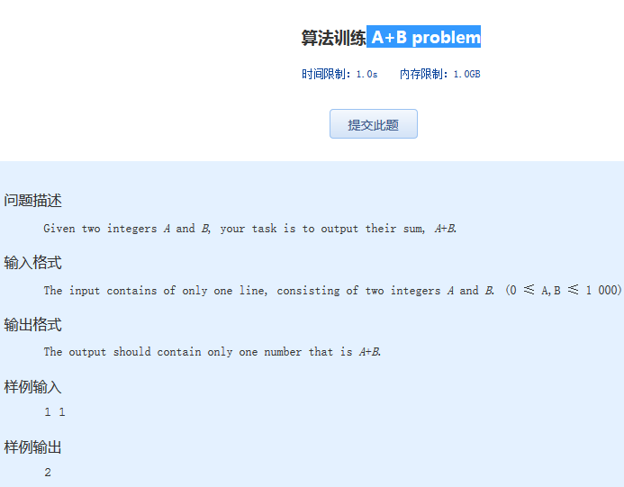 算法训练 A+B problem
时间限制：1.0s 内存限制：1.0GB

问题描述
Given two integers A and B, your task is to output their sum, A+B.
输入格式
The input contains of only one line, consisting of two integers A and B. (0 ≤ A,B ≤ 1 000)
输出格式
The output should contain only one number that is A+B.
样例输入
1 1
样例输出
2

